PHYS 202 HWK on E-field Name:________________________Due 2/13 12:30

PHYS 201 Equations of kinematics & Newton’s 2nd law are given below:

|  |  |  |  |  |
| --- | --- | --- | --- | --- |
| 1. | 2. | 3. | 4. | Newton’s 2nd Law: |
|  |  |  |  |  |

1. When *v* is constant (*v* = *v*0), the acceleration is ________. For this case, simplify equations 2 and 3.

2. Define electric field, identify it as a vector or scalar, and state its SI unit.

|  |
| --- |
|  |
| http://edugen.wileyplus.com/edugen/art2/common/pixel.gif |

3. [P52, Chap 18] The right drawing shows an electron entering the lower left side of a parallel plate capacitor and exiting at the upper right side. The initial speed of the electron is 5.71  × 106 m/s. The capacitor is 2.00 cm long, and its plates are separated y 0.150 cm.

a. When the capacitor plates are not charged, as in the left drawing, draw the subsequent motion of the electron, and determine how long the electron takes to cross the plates.

b. Assume that the electric field between the plates is uniform everywhere in the right drawing, and find its magnitude.

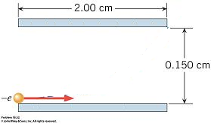 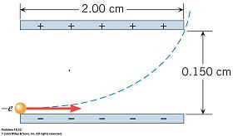

|  |  |  |  |  |
| --- | --- | --- | --- | --- |
|  |  |  |  |  |

4. Figure below shows an electron passing between two charged metal plates that create an electric field of 375 N/C, perpendicular to the electron’s original horizontal velocity. The initial speed of the electron is 3.00×106 m/s, and the horizontal distance it travels in the uniform field is 6.00 cm.   
(a) Sketch the electric field between the plates.  
(b) Sketch the path of the electron as it travels between the plates and exits.   
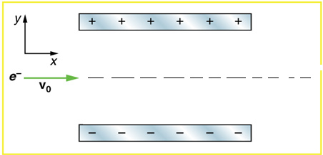  
(c) How long will it take the electron to cross the plates?

(d) What is the vertical acceleration of the electron? [me = 9.11 x 10-31kg, |qe| = 1.6 x 10-19C]

(e) What is its vertical deflection of the electron?

(f) What is the vertical component of its final velocity?

(g) At what angle, with the horizontal, does the electron exit?